Caracterización geométrica de un inyector common-rail solenoide para el modelado de procesos de inyección

Geometrical characterization of a solenoid common-rail injector for modelling the injection process

L. Robles-Lorite¹, A. Palomar-Torres¹, E. Torres-Jiménez¹, R. Dorado-Vicente¹, L. Lešnik²

¹Departamento de Ingeniería Mecánica y Minera, Universidad de Jaén, España. Email: lrl00024@red.ujaen.es, apalomar@ujaen.es, etorres@ujaen.es, rdorado@ujaen.es
2 Faculty of Mechanical Engineering, University of Maribor, Slovenia. Email: luka.lesnik@um.si

Resumen

Optimizar el proceso de inyección es fundamental para mejorar el rendimiento y las emisiones de un motor de combustión. Esta optimización es esencial al estudiar un nuevo biocombustible. El modelado de un sistema common-rail se centra en el inyector. Una simulación precisa del proceso de inyección requiere datos geométricos de los conductos internos y volúmenes. Sin embargo, esta información no la proporciona el fabricante. Por esta razón, los investigadores han desarrollado varias técnicas para solventar este problema; por ejemplo, el método de la silicona que se desarrolló originalmente para determinar la geometría interna de la boquilla de un inyector. En el presente trabajo, aplicamos esta metodología, junto con técnicas de medición convencionales, con el objetivo de proporcionar los datos necesarios para simular el proceso de inyección. Comparando los resultados más precisos obtenidos mediante rayos X, se concluye que la precisión del método de la silicona es fiable.

Palabras clave: Método silicona, geometría interna inyector, motor diésel, molde de silicona.

Abstract

The injection process plays an important role in optimizing the performance and emissions of an internal combustion engine. This kind of optimization becomes essential when a new biofuel is under study. When a common-rail system is analysed, the modelling of the injection system is focused on the injector. In this case, an accurate simulation of the injection process requires determining geometrical data of the internal ducts and volumes of the injector. Nevertheless, this information is not easy to get because it is not available from the manufacturer. For this reason, researchers have developed several techniques to overcome this problem; for example, the silicone methodology was originally developed to determine the internal geometry of an injector nozzle. In the present paper, we apply this methodology, together with conventional measurement techniques, to determine the internal geometry of a solenoid common-rail injector with the target of providing the necessary data for an accurate simulation of the injection process. Based on a comparison using high-quality results obtained from X-ray tests, we concluded that the accuracy of the silicone methodology is of confidence.

Keywords: Silicone Methodology, injector internal geometry, diesel engine, silicone mould.

Introduction

The target of the present paper is to determine the internal geometry of each component of a common-rail solenoid injector. Nowadays, new fuels are being tested as a substitute for petroleum-derived fuels in internal combustion engines (ICE). In this case, the optimization of the injection process leads to both saving fuel and reducing harmful emissions.
Today, road transport is one of the primary sources of air pollution in Europe [1], highlighting diesel vehicles as an important source of NO2 emissions. For this reason, restrictions are being made, resulting in increasingly stringent quality controls. One of the main objectives of the European Union is to achieve adequate air quality levels that avoid risks to human health and the environment. For this reason, the "Clean Air" policy was proposed in 2013 [2], which establishes the targets to reduce air pollution up to 2030 and, in particular, the directive on ambient air quality [3], which sets the appropriate targets taking into account the standards guidelines and related programs of the World Health Organization (WHO). Concerning polluting emissions caused exclusively by transport, the Regulation on emissions Euro 5 and Euro 6 for vehicles [4] stands out, which limits the emissions for both gasoline and diesel vehicles. Furthermore, the European Union considers that internal combustion engines are a key factor in gas emissions, and they must be designed following the ecological guidelines defined in the directive 2009/125 / EC [5]. In the last years, a lot of effort is being made to promote electric vehicles as substitutes for ICEs. Nevertheless, many researchers claim the significant advantages of these engines. For example, the greenhouse impact of electric vehicles is, in some cases, even higher than that of modern vehicles with sophisticated ICEs [6]. Other arguments supporting this position are the growing demand for transport, the strong development of cleaner and more efficient ICEs, the availability of fossil fuels, and the high energy density of conventional fuels [7]. For these reasons, it is still necessary to further investigate in the optimization of internal combustion engines for road applications, even when considering the best growth scenario for all-electric and hybrid vehicles. One of the key points in reducing emissions is the improvement of the combustion process, and therefore, of the injection process in diesel engines. For this reason, there is a constant search to find the optimal way to provide the appropriate fuel/air ratio together with low consumption and minimal polluting emissions.

Numerical simulation is a research method typically used to study the injection process [8],[9]. To build a numerical model that simulates the injection process in a common-rail system, it is necessary to know the internal geometry of the injector because it directly influences the atomization of the fuel inside the combustion chamber and, consequently, the combustion and exhaust emissions. For example, the air/fuel mixture inside the combustion chamber is determined by the number of nozzle holes, the hole diameter and angle, etc. [10]. The manufacturers never provide this information. For this reason, some researchers from the field of heat engines have focused their efforts on developing techniques to geometrically characterize each inner duct and volume of the injector and its moving parts. An example of these techniques is the silicone method. To perform the geometric characterization process that we have carried out, we have used both conventional measurement tools and the innovative “silicone method” proposed by Macián et al. [11]. These authors developed this technique just for the determination of the internal geometry of a diesel nozzle. The novelty of the present study is that we apply this method to several internal components of an injector different from the nozzle. The results obtained allowed us to make a complete 3D model of the selected injector and provide enough geometrical data for later use in the injector modelling process. Additionally, the accuracy of the silicone methodology was tested via comparison to X-ray measurements of the injector nozzle.

Materials and Methods

Inyector model

The injector under study is a solenoid common-rail injector model Denso 1600-BN800-07Q00017 used in NISSAN vehicles. For the determination of its internal geometry, it was disassembled. Some of its components were cut to be able to measure some internal ducts and volumes (Fig. 1); in particular, two cuts were made, one longitudinal and one transverse, so it was possible to measure the diameter variation in the fuel inlet channel.

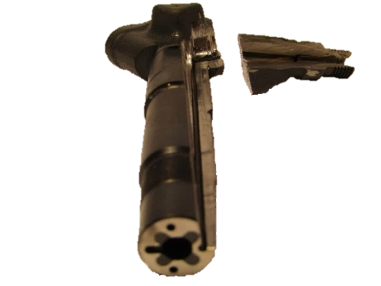
Figure 1. Cut in the injector body to measure the fuel inlet channel

Conventional measurements

The following conventional measurement devices were used for the geometrical characterization of both the internal and external geometry of the injector:

Profile projector

Model Nikon V-10AD/V-10 (Fig. 2). This device, apart from measuring distances in x and y, allows measuring angles. The length’s resolution is 0.001 mm, while the resolution for the angles is 0.01º. Its expanded uncertainty is indicated in its calibration certificate [12], being U95 = 8 µm for the x-axis and U95 = 5 µm for the y-axis.

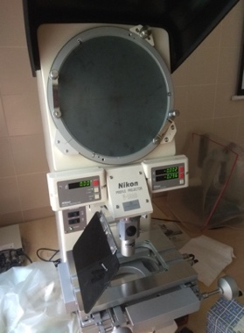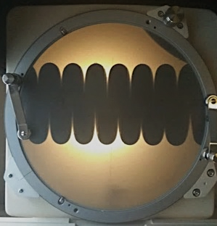
a) b)
Figure 2. a) Profile projector device, b) example of a measurement of the solenoid spring.

Calliper

Calliper (Fig.3) has a resolution is 1/m, where m is the number of divisions of the Vernier scale (metric). In our case, m = 50, and its resolution is 0.02 mm. As we do not have its calibration certificate, we will estimate its uncertainty based on its resolution, resulting in 0.01 mm.

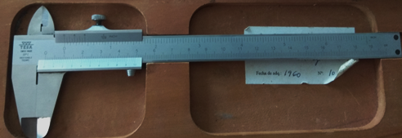
Figure 3. Calliper

Outside micrometer

Outside micrometer (Fig. 4) has a resolution of 0.02 mm since it has 50 divisions. As we do not have its calibration certificate, we will find its uncertainty as previously, that is, from its resolution, resulting in 0.01 mm.

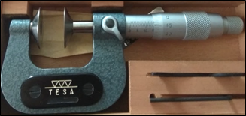
Figure 4. Outside micrometer

Inside micrometer

Inside micrometer (Fig. 5), with a resolution of 0.001 mm since it has 100 divisions. In this case, the manufacturer provided the micrometer uncertainty in the calibration certificate: U₉₅ = 2 µm.
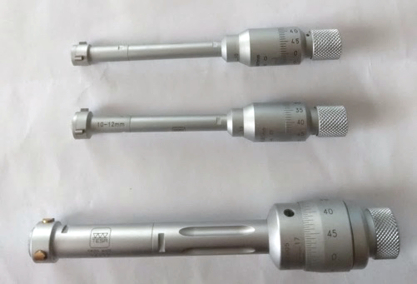
Figure 5. Inside micrometer

Each measurement was taken ten times in order to calculate the arithmetic mean $\overline{\text{x}}$according to Eq. 1:

$\overline{\text{x}}\text{ =}\frac{\sum_{\text{k}\text{=1}}^{\text{n}}{{\text{x}}_{\text{k}}}}{\text{n}}$ , (1)

where, n is the number of observations and x_{k} is each measure collected. The uncertainty of the measure was calculated as its standard deviation $s\left(\overline{\text{x}}\right)$ (Eq. 2), which is an uncertainty type A according to the Guide to the Expression of Uncertainty in Measurement [13]:

$s\left(\overline{\text{x}}\right) \text{=}\sqrt{\frac{\text{1}}{\text{n}\text{-1}}\sum_{\text{j=1}}^{\text{n}}{{{\text{(}\text{x}}_{\text{j}}\text{-}\overline{\text{x}}\text{)}}^{\text{2}}}}$. (2)

Silicone Methodology

The conventional devices described above don’t allow measuring some internal ducts and volumes of the injector since most of them have a complex geometry and small dimensions which can not be measured using conventional tools. For this reason, we decided to apply a novel technique developed by Macián et al. [11], which is based on the use of silicone. These authors make a silicone mould to be able to measure the internal geometry of an injector’s nozzle, which is one of the most important components when characterizing an injector since it influences fuel spray, combustion, and exhaust emissions [14],[15]. The big issue is the small diameter of each nozzle hole that is barely perceptible to the view. Hence, the complexity to measure it and the importance of knowing these diameters and their angle to know the jet's direction are critical. For these reasons, we are also going to verify our measurements obtained from the application of the silicone methodology. The validation will contrast our measurements obtained from the silicone moulds with those measurements obtained by applying the X-rays technique.

Noted that, when measuring silicone moulds, the measure can only be done via optical instruments as other conventional tools, such as the calliper or the micrometers, need contact to measure and, taking into account that the mould is very elastic, they could easily deform it leading to wrong results. In our case, we use the profile projector described above.

The silicone bought (Fig. 6) is commonly used in dentistry. Specifically, we have used the silicone: "Elite double 8" and "Elite double 16" together with their respective catalysts from the manufacturer Zhermack. Both differ in their elasticity and drying time, with 8 being much more elastic and taking longer to dry than 16.

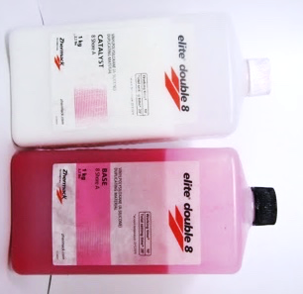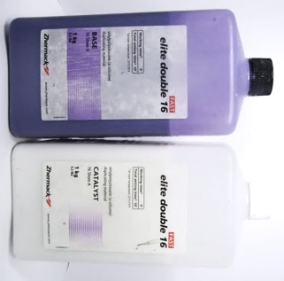
Figure 6. a) Silicone Elite Double 16, b) Silicone Elite Double 8.

The main steps to make a silicone mould are as follows:

- Clean the desired part in depth to remove any remaining fuel residues or any solid particles. A way to do it properly is by using an ultrasonic bath. In our case, we have used a solvent (acetone) to enhance the cleaning effect and to avoid a possible rust formation.
- Prepare the silicone blend: mix the base fluid (coloured one) with its respective catalyst (white fluid) in a 1:1 ratio, that is, the same amount of both products. Then, stir the blend for 1 minute.
- Pour the mixture into the hole to be measured and let it rest until it is completely dry. The drying time is indicated on each bottle, being ten minutes for the “Elite Double 16” and twenty minutes for the “Elite Double 8”.
- To appropriately pour the mixture into the cavities of complex geometry and minimal dimensions, a syringe with a needle is required to ensure that the silicone reaches the hole cavity. However, special care must be taken when sucking the mixture to avoid the formation of bubbles.
- Once the silicone has dried, extract the mould obtained by pulling it with the help of an object or using compressed air.

3D injector model

For the 3D design of the injector, we used the program “SolidWorks” version 2017, which is a CAD software that allowed us to reproduce the actual model. Firstly, we draw each piece and, after that, all the components were assembled. In addition, we used the "PhotoView 360", which is a plug-in to render the pieces and allows obtaining photographs of the model with great realism.

Results

Conventional procedure: results obtained

Table 1 shows an example of some measures obtained using the profile projector in regular pieces, while Table 2 makes the same for silicone moulds. Table 3 shows an example of some measurements obtained using the calliper and micrometers in regular pieces. The dimensions’ nomenclature is explained in Figs.

Table 1. Example of measurements obtained using the profile projector in the injector needle.

 | Dimension
 | D1 | L1 | R1 | R2 | D2 | L5 | L6
1 | 2.176 | 3.581 | 0.101 | 0.373 | 3.998 | 2.312 | 2.896
2 | 2.171 | 3.561 | 0.098 | 0.340 | 4.006 | 2.323 | 2.900
3 | 2.154 | 3.559 | 0.098 | 0.344 | 4.003 | 2.307 | 2.908
4 | 2.156 | 3.572 | 0.093 | 0.326 | 4.005 | 2.320 | 2.906
5 | 2.181 | 3.564 | 0.095 | 0.313 | 3.994 | 2.305 | 2.912
6 | 2.174 | 3.560 | 0.103 | 0.346 | 3.997 | 2.303 | 2.906
7 | 2.157 | 3.556 | 0.106 | 0.348 | 3.995 | 2.306 | 2.905
8 | 2.180 | 3.577 | 0.099 | 0.359 | 4.001 | 2.312 | 2.907
9 | 2.176 | 3.560 | 0.099 | 0.326 | 4.003 | 2.317 | 2.905
10 | 2.158 | 3.570 | 0.100 | 0.344 | 4.006 | 2.312 | 2.908
 | Mean value
 | 2.168 | 3.566 | 0.099 | 0.342 | 4.001 | 2.312 | 2.905
 | Uncertainty
 | 0.011 | 0.008 | 0.004 | 0.017 | 0.005 | 0.007 | 0.004

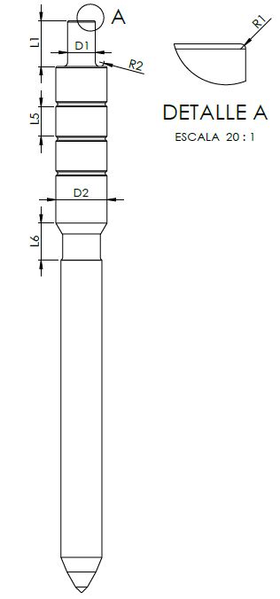
Fig. 7. Scheme of the injector needle with nomenclature.

Table 2. Example of measurement obtained using the profile projector in a silicone mould of the nozzle.

Dimension  Measurement | Di1 | αi1 | Di1' | Di4
1 | 3.910 | 59.40 | 3.892 | 0.146
2 | 3.915 | 59.38 | 3.89 | 0.149
3 | 3.912 | 59.10 | 3.88 | 0.144
4 | 3.918 | 59.23 | 3.887 | 0.146
5 | 3.921 | 59.24 | 3.894 | 0.144
6 | 3.920 | 59.06 | 3.893 | 0.150
7 | 3.910 | 59.16 | 3.889 | 0.148
8 | 3.910 | 59.42 | 3.888 | 0.142
9 | 3.910 | 59.52 | 3.888 | 0.150
10 | 3.910 | 59.06 | 3.893 | 0.144
Mean value | 3.914 | 59.26 | 3.889 | 0.146
Uncertainty | 0.005 | 0.16 | 0.004 | 0.003

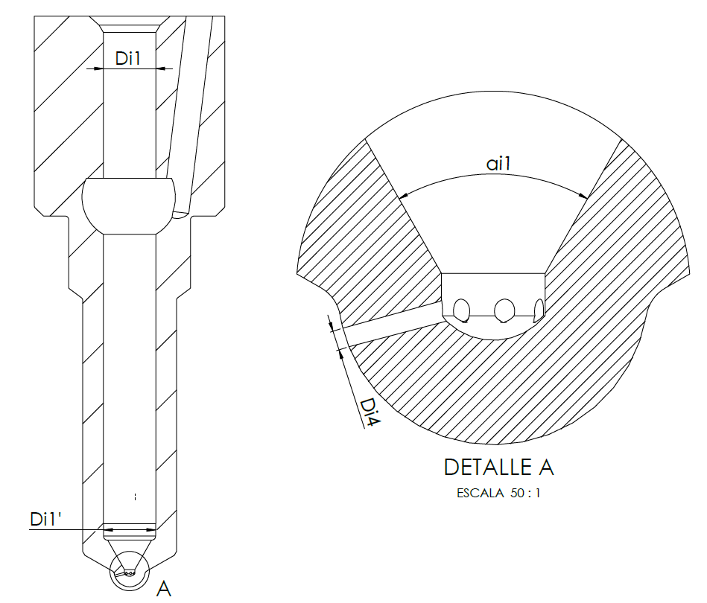
Fig. 8. Scheme of the injector nozzle with nomenclature.

Table 3. Example of measurement obtained using the calliper and micrometers in the body of the injector.

Dimension  Measurement | De1 | De2 | de1 | de2
1 | 27.245 | 38.72 | 19.35 | 8.71
2 | 27.268 | 38.63 | 19.29 | 8.75
3 | 27.275 | 38.64 | 19.43 | 8.82
4 | 27.245 | 38.65 | 19.20 | 8.80
5 | 27.28 | 38.63 | 19.35 | 8.83
6 | 27.328 | 38.70 | 19.32 | 8.77
7 | 27.324 | 38.67 | 19.34 | 8.75
8 | 27.263 | 38.65 | 19.24 | 8.70
9 | 27.246 | 38.62 | 19.38 | 8.85
10 | 27.264 | 38.64 | 19.40 | 8.83
Mean value | 27.274 | 38.655 | 19.330 | 8.781
Uncertainty | 0.030 | 0.032 | 0.071 | 0.053
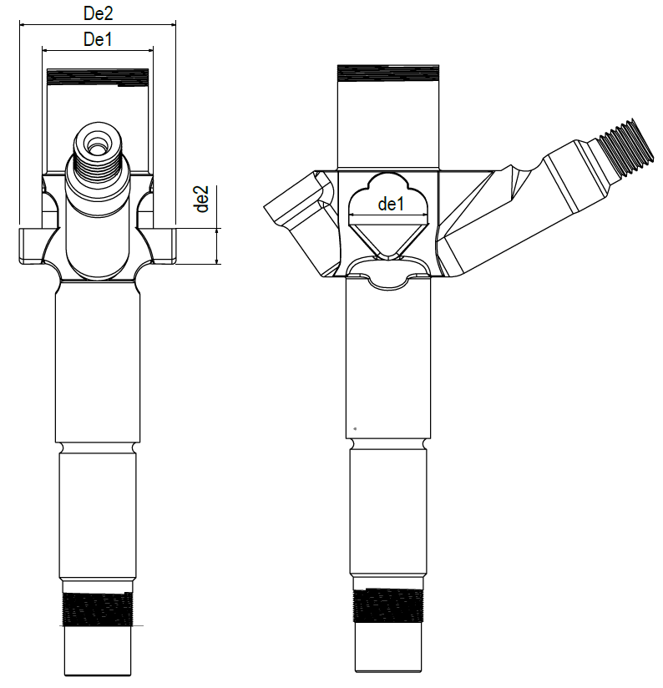
Fig. 9. Scheme of the injector body with nomenclature.

Silicone methodology: results and validation

Figs. 10 and 11 show an example of some moulds obtained from different parts of the injector.
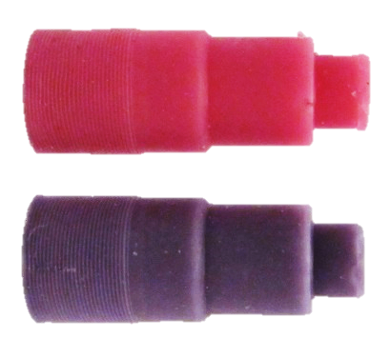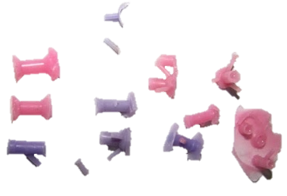
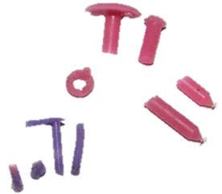
Fig. 10. Moulds obtained from several parts and ducts of the injector.

Fig. 11. Silicone mould of the injector nozzle.
The silicone method was validated by comparing four internal dimensions of the injector nozzle (see Table IV). Nozzle dimensions were measured using the profile projector and a microscope (Fig. 12), which lead us to model the silicone mould (Fig. 13). These dimensions were also measured by X-rays (Fig. 14 and 15), which is a more accurate method and, consequently, can be taken as a reference to calculate the measurement error (Table 4).

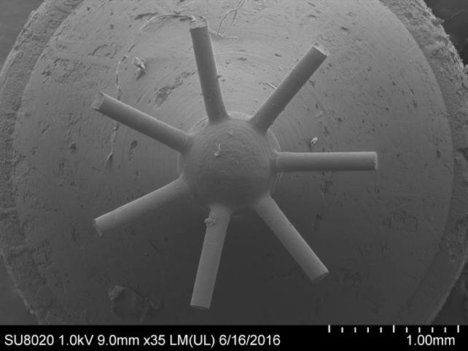
Fig. 12. Microscope image of the silicone mould of the nozzle.

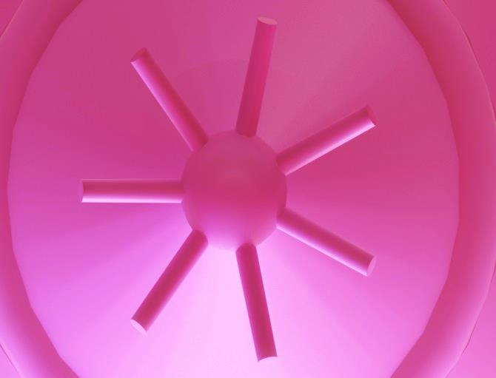
Fig. 13. 3D model of the Silicone mould of the injector nozzle obtained via Solidworks and using our measurements.

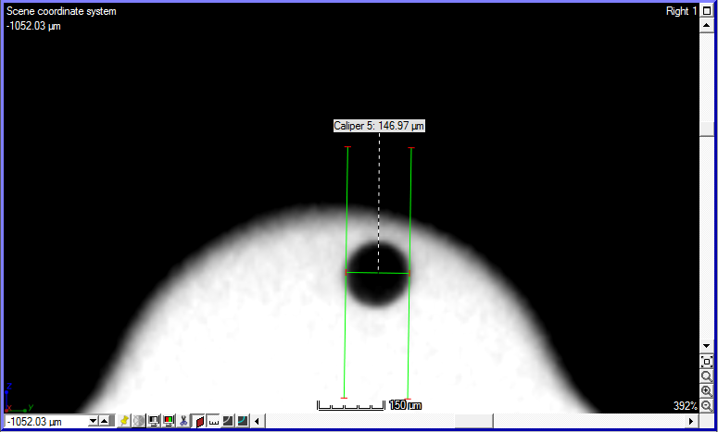
Fig. 14. Nozzle outlet orifice measured by X-rays.

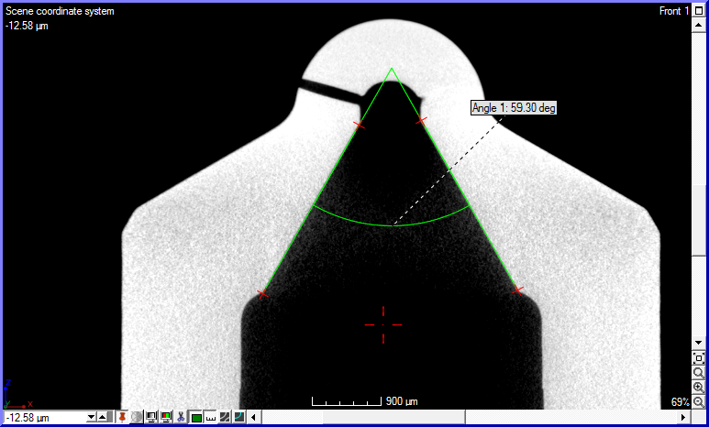
Fig. 15. Nozzle internal cavity measured by X-rays.

Table 4. Measurements in the nozzle using the silicone method and the X-ray method.
 | Silicone Method | X-Rays | Relative error (%)
Hole outlet diameter | 0.146 ± 0,003 | 0.14697 | 0.0666
Internal Angle | 59.26 ± 0.16 | 59.30 | 0.0725
Tip diameter | 3.914 ± 0,005 | 4.01702 | 2.5745
Internal diameter | 3.889 ± 0,004 | 4.00027 | 2.7716

In view of the results shown in Table 4, we can conclude that the silicone method is a reasonably accurate measurement method since the errors obtained are lower than 3%.

3D model

After modelling all components of the injector in the CAD software, they can be assembled to obtain the geometric model of the hole injector and any cut view (Fig. 16). Fig. 17 shows an actual photo of one component of the injector, as well as the model made in Solidworks.

Fig. 16. 3D Solidworks model of the hole injector and a section view.

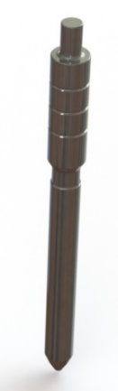
a) b)
Fig. 17. Needle: a) actual picture, b) simulated.

Conclusions

In the present paper, we have shown how to characterize an injector of a common-rail injection system geometrically. Conventional and new techniques have been applied, leading to a complete 3D model performed in Solidworks. This model is intended for providing the necessary geometrical data required in future work dealing with the numerical simulation of the injection process of new biofuels. The new methodology tested is the silicone method, which was developed initially to characterize the injector nozzle geometrically. In our work, we have applied this methodology to other parts of the injector with good results. The accuracy of the silicone methodology was tested by comparison with measurements obtained from X-ray tests, and we can conclude that it is highly confident (error < 3%).

Acknowledgement
This work was supported by the Spanish Ministry of Science, Innovation, and Universities [RTI2018-095923-B-C21].

References

- EEA Report No 10/2019,”Air quality in Europe – 2019 report”, Publications Office of the European Union, Luxembourg, 2019
- COM (2013) 918 final ,“Programa «Aire Puro» para Europa”, Comisión Europea, Bruselas, 2013
- Directive 2008/50/EC of the European Parliament and of the Council of 21 May 2008 on ambient air quality and cleaner air for Europe OJ L 152, 11.6.2008, p. 1–44.
- Commission Regulation (EU) 2017/1154 of 7 June 2017 amending Regulation (EU) 2017/1151 supplementing Regulation (EC) No 715/2007 of the European Parliament and of the Council on type-approval of motor vehicles with respect to emissions from light passenger and commercial vehicles (Euro 5 and Euro 6) and on access to vehicle repair and maintenance information.
- Directive 2009/125/EC of the European Parliament and of the Council of 21 October 2009 establishing a framework for the setting of ecodesign requirements for energy-related products.
- L. Lešnik, B. Kegl, E. Torres-Jiménez and F. Cruz-Peragón, “Why we should invest further in the development of internal combustion engines for road applications”, Oil & Gas Science and Technology–Revue d’IFP Energies nouvelles (2020) Vol. 75, pp. 56.
- J.R. Serrano, R. Novella and P. Piqueras, “Why the development of internal combustion engines is still necessary to fight against global climate change from the perspective of transportation”, Applied Sciences (2019). Vol. 9, pp. 4597.
- E. Torres-Jimenez, R. Dorado, B. Kegl and M. Kegl, “One-dimensional modeling and simulation of injection processes of bioethanol-biodiesel and bioethanol-diesel fuel blends”, Fuel (2018). Vol. 227, pp. 334-344.
- L. Lešnik, B. Vajda, Z. Žunič, L. Škerget and B. Kegl, “The influence of biodiesel fuel on injection characteristics, diesel engine performance, and emission formation”, Applied energy (2013). Vol. 111, pp. 558-570.
- K. Mollenhauer and H. Tschoeke, Handbook of Diesel Engines, Springer (2010).
- V. Macián, V. Bermúdez, R. Payri and J. Gimeno, “New technique for determination of internal geometry of a diesel nozzle with the use of silicone methodology”, Experimental techniques (2006). Vol. 27, pp. 39-43.
- Centro Español de Metrología, 1999, Procedimiento DI-001 para la Calibración de Proyectores de Perfiles, 1ªed, CEM, Madrid.
- JCGM/WG1. Guide to the Expression of Uncertainty in Measurement. International Organization for Standardization: Geneva, (Switzerland), 2008.
- S. H. Yonn, J. P. Cha, C. S. Lee, “An investigation of the effects of spray angle and injection strategy on dimethyl ether (DME) combustion and exhaust emission characteristics in a common-rail diesel engine”, Fuel Processing Technology (2010). Vol. 11, pp. 1364-1372.
- B. H. Lee, “Effect of the number of fuel injector holes on characteristics of combustion and emissions in a diesel engine”, International Journal of Automotive Technology (2010). Vol. 6, pp. 783-791.

