Exergy analysis of an absorption refrigeration system using pair working fluid water-ammonia

Thais Martins da Silva Lima¹, Antonio Gabriel Souza Almeida²

¹Núcleo de Refrigeração, Climatização e Automação, Campus Salvador, Instituto Federal da Bahia, Brasil. Email: thaimartins23@gmail.com
2 Núcleo de Refrigeração, Climatização e Automação, Campus Salvador, Instituto Federal da Bahia, Brasil. Email: gabrielalmeida@ifba.edu.br

Abstract

The current work presents an exergy analysis of each component of an absorption refrigeration system using water-ammonia as working fluids and with a rectifier in the generator output. A static simulation was performed with fixed temperatures and heat input, thus obtaining the thermodynamic state of each point, then the value of the Coefficient of Performance (COP) and the exergetic efficiency was calculated. The COP behavior, efficiency, cooling capacity and irreversibilities were also analyzed for each component due to the variation in the condensation temperature, evaporation temperature and the heat of the gases supplied to generator. The analysis developed in this study also shows that ways to improve absorption refrigeration systems should focus on developing more efficient components, in particular the generator, heat exchanger and the absorber, all of which presented high exergy losses in the system.

Keywords: absorption refrigeration system; water-ammonia; exergy analysis; rectifier; thermodynamic modeling.

Resumo

A preocupação crescente com o desenvolvimento de sistemas que atendam requisitos de eficiência energética é um dos desafios da engenharia. Optar por sistemas de refrigeração com ciclo por absorção, em substituição de sistemas por compressão de vapor, se torna uma boa alternativa, devido às possibilidades de utilização de rejeitos térmicos de processos industriais e sistemas de potência como insumo energético. O presente trabalho visa apresentar a análise exergética detalhada de cada componente envolvido no sistema de refrigeração por absorção, usando par água-amônia. Um modelo termodinâmico foi desenvolvido fazendo o uso de rotinas da plataforma EES com a aplicação da Primeira e Segunda Lei da Termodinâmica, levando em consideração as diferentes variáveis envolvidas a fim de torná-lo o mais próximo do real possível. Por meio dessa análise é possível identificar os principais pontos de perda de eficiência do ciclo e assim direcionar os esforços no sentido de aperfeiçoar o desempenho do sistema.

Palavras chave: refrigeração por absorção, água-amônia, análise exergética, retificador, modelagem termodinâmica

Introduction

It is estimated that approximately 15% of all electricity produced in the whole world is used for refrigeration and air-conditioning processes [1]. About 80% of electricity is still generated by burning fossil fuels, leading to non-stop emissions of greenhouse effect gases [2]. It is crucial to decrease the consumption of unsustainable fossil fuel and promote the use of sustainable energy technology to handle the growing demand for energy for refrigeration.
The electric power needed to start the operation of a pump in an absorption refrigeration system is significantly lower than the amount needed to start a compressor of a vapor compression refrigeration system. This is because most of the energy needed in an absorption system is thermal and it can come from either thermal waste from industrial processes or power systems in general, which is usually discarded into the environment.
However, in spite of the advantages of absorption systems, vapor compression refrigeration systems dominate the market. One of the reasons for this is that they have a lower COP (Coefficient of performance) value in comparison to compression refrigeration systems. The value of COP for absorption refrigeration systems is often between 0.4 and 0.8 for single-effect absorption systems.
Therefore to promote the use of absorption systems researchers have attempted to improve their performance, identifying losses and taking a careful look at system improvements to ensure performance advances and lower cost.
This work presents exergetic analysis of a single-effect absorption refrigeration system, using water-ammonia working fluids. A detailed analysis of each component associated with the cycle was made. It is assumed that there is a rectifier at the generator output the main function of which is to decrease or eliminate any traces of the absorbent fluid in the refrigerant fluid.

Literature review

Absorption refrigeration cycles with water-ammonia

A single-effect water-ammonia absorption refrigeration system, in the simplest form, is shown in Fig. 1. When the refrigerant vapor – ammonia comes out of the generator with traces of water, it flows to the rectifier, where the little quantity of water that is still in there condensates. The refrigerant vapor, which is nearly pure, goes into the condensator, where heat exchange occurs, and the vapor turns into liquid. The liquid ammonia passes through the expansion valve 1, where its pressure and temperature are decreased in an isenthalpic ideal process, becoming biphasic. The ammonia flows to the evaporator where it turns into vapor again when it receives a heat flow from the environment of interest. Following that, the refrigerant vapor comes into the absorber and then it is absorbed by the weak solution in the absorbent fluid water. The pressure of the strong solution, rich in ammonia, rises as it is pumped and sent to the generator. There is a heat exchanger situated between the generator and the absorber which uses thermal energy from the solution that comes out of the generator. As it has a high temperature, the temperature of the solution increases and it is taken from the pump to the generator. Also, the temperature of the solution which goes from the generator to the absorber falls and, consequently, the necessary heat flow is will be expelled from the absorber to cool the biphasic solution. At this stage, the cycle restarts.
The heat exchanger is an important component in the reuse of heat flows, representing a 60% increase in COP for the same system without the heat exchanger[3].

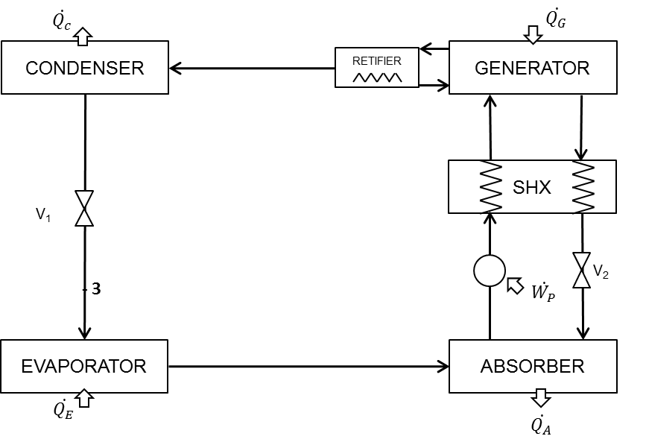
Figure 1: Single-effect absorption refrigeration system [3]

[3] review the literature on absorption refrigeration technology, such as various types of absorption refrigeration systems, research on working fluids, and improvement of absorption processes. The characteristics of the system are shown and a comparison based on pressure, operating temperature, working fluid, cooling power, COP and current status of systems was carried out: Systems like single-effect absorption system, multi-effect absorption refrigeration cycle, absorption refrigeration cycle with GAX (Generator-Absorber Heat Exchangers),absorption refrigeration cycle with an absorber-heat-recovery, half-effect absorption refrigeration cycle, combined vapor absorption-compression cycle, sorption-resorption cycle, dual-cycle absorption refrigeration, combined ejector-absorption refrigeration cycle, osmotic-membrane absorption cycle, Self-circulation absorption system using LiBr/water and diffusion absorption refrigeration system.
[4] provide a comprehensive review of several different GAX cycle configurations. The choice of working fluids and the performance of the GAX cycle in terms of coefficient of performance and temperature increase are also presented. The study reveals an improvement in the COP of about 10–20%, 20–30% and 30–40% in the absorber with heat recovery cycle, simple GAX and branched GAX cycle, respectively, when compared to a conventional single effect system for the same operating conditions.
[5] provide an update on alternative cooling technologies, including some state of art systems. They briefly present six cooling technologies that have high performance potential and potential to replace vapor compression equipment: absorption and adsorption cooling systems, desiccant cooling, magnetic cooling, thermoacoustic cooling, thermoelectric cooling and transcritical CO2.
The study by [6] gives information on a gas engine driven hybrid air conditioning system that was simulated and built; it consisted of a gas engine, a single-stage compression-type refrigerator, and a single-effect absorption-type refrigerator that can be driven by shaft power and waste heat, respectively, from the gas engine. In the simulation results, the system COP at the design point was about 1.87 and, at 50% partial load operation, the performance increased by 14% because of the simultaneous manipulation of the input gas flow rate and hot water flow rate. The validity of the simulation was confirmed by experiments carried out using the actual constructed machine.
[7] do both an energy and exergy analysis of a refrigeration system with two refrigeration cycles in cascade, compression and absorption. The pair of fluids lithium bromide-water (LiBr-H2O) and water-ammonia(NH3-H2O) for the absorption cycle were compared to each other to determine the most suitable. After the pair of fluids in the absorption section of the system is determined – LiBr-H2O –, the thermodynamic analyses for different working temperatures of the system components were made based on both the first and second laws and using the following refrigerants: NH3, R134a, R410A and CO2, in the section of vapor compression.
[8] examine the performance of a commercially available absorption refrigeration system experimentally. The work consists of a more detailed experimental analysis of a refrigeration system ACD-3600 – manufactured by Robur. The results were not positive at the beginning of the study. The schematic diagram of the cycle is illustrated in Fig. 2. The absorption refrigeration system operates with natural gas and uses water-ammonia fluid, with a cooling capability of 10 kW.

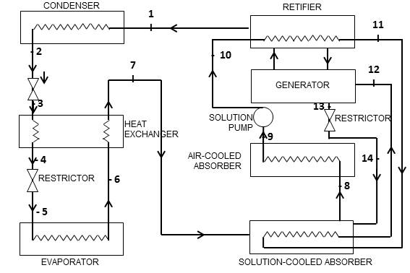
Figure 2: Absorption refrigeration system ACD-3600 – producer Robur [8]

One of the main challenges related to absorption refrigeration systems with water-ammonia working fluids is the separation between water vapor and ammonia vapor in the generator. As a result of partial separation, the ammonia vapor which comes out of the generator always contains a small amount of water. This vapor is enters the condensator, then goes through the expansion device and finally through the evaporator, where it tends to accumulate. As there is water in the evaporator, the evaporation temperature rises slightly and both the performance and efficiency of the system decreases [9].
[10] mentions that ignoring the water content in the vapor which comes out of the generator is one of the main mistakes in designing an absorption refrigeration system with water-ammonia working fluid. This is why it is really important to choose the most suitable process of purification to reduce the water content in the ammonia refrigerant fluid, to ensure both reliable and efficient operation.
[11] analyze the importance of the ammonia purification process in ammonia–water absorption systems. They also present an analysis of the influence of the components in the distillation columns, the efficiency achieved in the distilled concentration, identifying and qualifying the effects of a concentration of distillate in the system, working conditions and performance. When a rectification column is used, the increase in the reflux rate raises the ammonia concentration, however, the COP of the distillation system tends to rise or also decrease. When the best efficiency is used in the rectification column (E=1), an ideal value for the reflux rate is found. An ideal value for the reflux rate occurs when a value is slightly lower than the value found when the concentration of ammonia is equal to one unit. Moreover, for fixed values of evaporation and absorption/condensation temperatures, an ideal combination of temperature in the generator for the reflux rate is obtained.
[12] present a thermal model of a distillation column with a capacity of 17.58 kW (5 TR) in an absorption refrigeration cycle with water-ammonia. They analyze the process of wet ammonia vapor purification in the distillation column and estimate the necessary geometry to reach desired values for purity.
[9] present a detailed study about the process of rectification of water-ammonia fluids in absorption systems using a helical rectifier. A mathematical model of a water-ammonia helical rectifier is presented based on a heat generator combined with mass transfer equations in liquid and vapor phases.

Method

Modelling of refrigeration cycle

Equations (1) to (51) show the modeling of each control volume in a thermodynamic cycle based on mass and species conservation, both using the First and Second Law of Thermodynamics and calculating the irreversibility of each component.

Condenser |  |  | Expansion valve 1
$${\dot{m}}_{1}={\dot{m}}_{2}$$ |  | (1) | $${\dot{m}}_{2}={\dot{m}}_{3}$$ |  | (2)
$${\dot{m}}_{1}∙X_{1}={\dot{m}}_{2}∙X_{2}$$ |  | (3) | $${\dot{m}}_{2}∙X_{2}={\dot{m}}_{3}∙X_{3}$$ |  | (4)
$$Q_{C}={\dot{m}}_{1}(h_{1}-h_{2})$$ |  | (5) | $$h_{2}=h_{3}$$ |  | (6)
$${Ex}_{C}=-(1-({T_{0}}/{T_{C}))∙Q_{C}}$$ |  | (7) | $$I_{V1}=\left({{\dot{m}}_{2}∙ex}_{2}\right)-\left({{\dot{m}}_{3}∙ex}_{3}\right)$$ |  | (8)
$$I_{C}=\left({\dot{m}}_{1}∙{ex}_{1}\right)-\left({{\dot{m}}_{2}∙ex}_{2}\right)+((1-({T_{0}}/{T_{C}))∙Q_{C}})$$ |  | (9)
Evaporator |  |  | Absorber
$${\dot{m}}_{3}={\dot{m}}_{4}$$ |  | (10) | $$T_{A}={T_{4}+T_{5}+T_{10}}/3$$ |  | (11)
$${\dot{m}}_{3}∙X_{3}={\dot{m}}_{4}∙X_{4}$$ |  | (12) | $${\dot{m}}_{5}={\dot{m}}_{4}+{\dot{m}}_{10}$$ |  | (13)
$$Q_{E}={\dot{m}}_{3}(h_{4}-h_{3})$$ |  | (14) | $${\dot{m}}_{5}∙X_{5}={\dot{m}}_{4}∙X_{4}+{\dot{m}}_{10}∙ X_{10}$$ |  | (15)
$${Ex}_{E}=-(1-({T_{0}}/{T_{E}))∙Q_{E}}$$ |  | (16) | $$Q_{A}=\left({\dot{m}}_{5}∙h_{5}\right)-\left({\dot{m}}_{4}∙h_{4}\right)-\left({\dot{m}}_{10}∙ h_{10}\right)$$ |  | (17)
$$I_{E}=\left({\dot{m}}_{3}∙{ex}_{3}\right)-\left({{\dot{m}}_{4}∙ex}_{4}\right)+((1-({T_{0}}/{T_{E}))∙Q_{E}})$$ |  | (18) | $${Ex}_{A}=-(1-({T_{0}}/{T_{A}))∙Q_{A}}$$ |  | (19)
 |  |  | $$I_{A}=\left({\dot{m}}_{4}∙{ex}_{4}\right)+\left({\dot{m}}_{10}∙ {ex}_{10}\right)-\left({\dot{m}}_{5}∙{ex}_{5}\right)+\left((1-({T_{0}}/{T_{A}))∙Q_{A}}\right)$$ |  | (20)
Pump |  |  | Rectifier
$${\dot{m}}_{5}={\dot{m}}_{6}$$ |  | (21) | $${\dot{m}}_{6}={\dot{m}}_{13}$$ |  | (22)
$${\dot{m}}_{5}∙X_{5}={\dot{m}}_{6}∙X_{6}$$ |  | (23) | $${\dot{m}}_{11}={\dot{m}}_{1}{\dot{+m}}_{12}$$ |  | (24)
$$W_{P}=v_{5}\left({\left(P_{6}-P_{5}\right)}/{Efic}\right)∙{\dot{m}}_{5}$$ |  | (25) | $${\dot{m}}_{6}∙X_{6}={\dot{m}}_{13}∙X_{13}$$ |  | (26)
$$h_{6}=h_{5}+\left({W_{p}}/{{\dot{m}}_{5}}\right)$$ |  | (27) | $${\dot{m}}_{11}∙X_{11}={\dot{m}}_{1}{\dot{∙X_{1}+m}}_{12}∙X_{12}$$ |  | (28)
$$h_{6}=h_{5}+\left({W_{p}}/{{\dot{m}}_{5}}\right)$$ |  | (29) | $$\left({\dot{m}}_{13}∙ h_{13}\right)-\left({\dot{m}}_{6}∙h_{6}\right)=\left({\dot{m}}_{1}∙ h_{1}\right)+ \left({\dot{m}}_{12}∙ h_{12}\right)-\left({\dot{m}}_{11}∙h_{11}\right)$$ |  | (30)
$$I_{P}=\left({\dot{m}}_{5}∙{ex}_{5}\right)-\left({\dot{m}}_{6}∙{ex}_{6}\right)+\left(W_{P}\right)$$ |  | (31) | $$I_{R}=\left({\dot{m}}_{11}∙{ex}_{11}\right)+\left({\dot{m}}_{6}∙{ex}_{6}\right)-\left({\dot{m}}_{1}∙{ex}_{1}\right)-\left({\dot{m}}_{13}∙{ex}_{13}\right)-\left({\dot{m}}_{12}∙{ex}_{12}\right)$$ |  | (32)
Heat exchanger |  |  | Generator
$T_{9}=\left({Efic}_{TC}∙T_{13}\right)+\left(\left(1-{Efic}_{TC}\right)*T_{8}\right)$[13] | (33) |  | $$T_{G}={T_{7}+T_{8}+T_{11}+T_{12}}/3$$ | (34)
$${\dot{m}}_{13}={\dot{m}}_{7}$$ | (35) |  | $${\dot{m}}_{7}+{\dot{m}}_{12}={\dot{m}}_{11}+{\dot{m}}_{8}$$ | (36)
$${\dot{m}}_{8}={\dot{m}}_{9}$$ | (37) |  | $${\dot{m}}_{7}∙X_{7}+{\dot{m}}_{12}∙X_{12}={\dot{m}}_{11}∙X_{11}+{\dot{m}}_{8}∙X_{8}$$ | (38)
$${\dot{m}}_{13}∙X_{13}={\dot{m}}_{7}∙X_{7}$$ | (39) |  | $$Q_{G}=\left({\dot{m}}_{1}∙h_{1}\right)+\left({\dot{m}}_{13}∙h_{13}\right)+\left({\dot{m}}_{8}∙h_{8}\right)-\left({\dot{m}}_{7}∙h_{7}\right)-\left({\dot{m}}_{6}∙ h_{6}\right)$$ | (40)
$${\dot{m}}_{8}∙X_{8}={\dot{m}}_{9}∙X_{9}$$ | (41) |  | $${Ex}_{G}=-(1-({T_{0}}/{T_{G}))∙Q_{G}}$$ | (42)
$$\left({\dot{m}}_{9}∙ h_{9}\right)-\left({\dot{m}}_{8}∙h_{8}\right)=\left({\dot{m}}_{7}∙ h_{7}\right)-\left({\dot{m}}_{13}∙ h_{13}\right)$$ | (43) |  | $$I_{G}=\left({\dot{m}}_{7}∙{ex}_{7}\right)+\left({\dot{m}}_{12}∙ {ex}_{12}\right)-\left({\dot{m}}_{11}∙{ex}_{11}\right)-\left({\dot{m}}_{8}∙{ex}_{8}\right)+\left((1-({T_{0}}/{T_{G}))∙Q_{G}}\right)$$ | (44)
$$I_{HE}=\left({\dot{m}}_{8}∙{ex}_{8}\right)+\left({\dot{m}}_{13}∙{ex}_{13}\right)-\left({\dot{m}}_{7}∙{ex}_{7}\right)-\left({\dot{m}}_{9}∙X_{9}\right)$$ | (45)
Expansion valve 2 |  |  | Coefficient of Performance
$${\dot{m}}_{9}={\dot{m}}_{10}$$ | (46) |  | $$COP(\%)=\left({Q_{E}}/{\left(Q_{G}+W_{P}\right)}\right)$$ | (47)
$${\dot{m}}_{9}∙X_{9}={\dot{m}}_{10}∙X_{10}$$ | (48)
$$h_{9}=h_{10}$$ | (49) |  | Exergetic Efficiency
$$I_{V2}=\left({{\dot{m}}_{9}∙ex}_{9}\right)-\left({{\dot{m}}_{10}∙ex}_{10}\right)$$ | (50) |  | $$ε_{REFRI} (\%)=\left({{Ex}_{E}}/{{Ex}_{G}}\right)∙100$$ | (51)

Absorption refrigeration cycle

The modeled absorption refrigeration cycle with water-ammonia is illustrated in Fig. 3. In addition to each component, each point of the thermodynamic state analysis is shown as well as both the heat and work exchanges that could occur. The simulation model was developed using Engineering Equation Solver (EES) software[14].

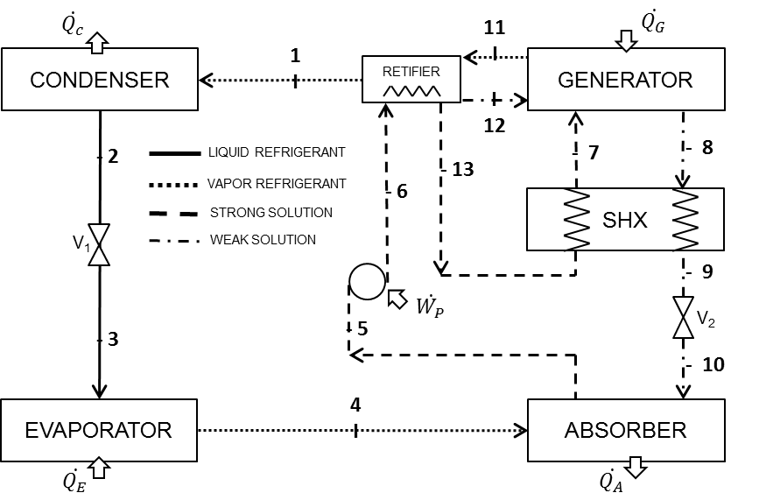
Figure 3: Absorption refrigeration cycle with water-ammonia modeled

General considerations

The following assumptions were adopted for the modeling:
- All the processes are internally reversible
- The control volumes operate in steady state
- The effects of both kinetic and potential energy are not considered
- There is no heat loss in the pipes
- The load losses are ignored in relation to the system as a whole
- There are not any changes in pressure, except through restriction devices and the pump. Thus, there are just two levels of pressure in the cycle
- The restriction devices are adiabatic, therefore the input enthalpy will be the same as the output enthalpy in these devices.

Design parameters

The energy efficiency of the pump in consideration is 50% [11].
The efficiency of the solution heat exchanger is 70% [15].
Saturation points based on [16] were adopted at the points 2, 5, 8 and 12 there is just saturated liquid, which means that mass percentages at these points are equal to 0 (zero) and at the points 1, 4 and 11 there is just dry saturated vapor; thus, the mass percentages at these points are equal to 1 (one)
The adopted concentration of refrigerant in the simulation was 0.999. This is considered high and it was recommended by 10] to guarantee the confiability and efficiency of absorption refrigeration systems with water-ammonia
The difference between the strong solution and the weak solution concentrations was considered as 0.1 [16]
The environment conditions are 35ºC for temperature and 101kPa for pressure
It is assumed that the solution which comes out of the absorber is at condensation temperature [16]
Determining the output state in the generator, it is considered that the solution which comes out is at saturation temperature
Determining the output state of the water in the rectifier, it is assumed that the enthalpy is the same as in the saturated solution.

Results and discussion

Simulation

The results presented in this section show an specific situation, with a condensation temperature of 45°C, an evaporation temperature of 5°C, the temperature of the gases entering the generator at 130°C [17] and transferred heat by the gases entering the generator [18] at 27.23 kW.
Table 1 shows the thermodynamic states and the specific exergy of each point determined by the computer simulation.
Quality of working fluid Q ¼ 0 means saturated liquid, Q ¼ 1 means saturated vapor, Q < 0 means subcooled state and Q > 1 means superheated state. The value “-0.001” is used by EES to indicate that the fluid is in a compressed liquid state.
The heat transfer rates of system components, given by the application of conservation of mass, conservation of specie and the First Law of Thermodynamics are illustrated in Table 2.
The only work supplied to the cycle is executed by the pump (0.9112 kW).
The exergy transfer rates associated with the heat in the system components, which are obtained by both the First and Second Laws of Thermodynamics, are presented in Table 3.
The irreversibilities of each component are given in Table 4 and Fig. 4 presents values in terms of percentages in relation to the total value of irreversibility in the system.

Table1. Thermodynamic states
Point | T  [K] | P  [bar] | X | h [kJ/kg] | s [kJ/kgK] | v  [m³/kg] | Quality  - | m  [kg/s] | ex  [kJ/kg]
1 | 327.2 | 17.82 | 0.999 | 1302 | 4.143 | 0.07362 | 1 | 0.03087 | 402.8
2 | 318.1 | 17.82 | 0.999 | 215.3 | 0.7368 | 0.001757 | 0 | 0.03087 | 366.1
3 | 250.5 | 1.689 | 0.999 | 215.3 | 0.8886 | 0.1664 | 0.2373 | 0.03087 | 319.3
4 | 278.1 | 1.689 | 0.999 | 1304 | 5.204 | 0.7914 | 1 | 0.03087 | 78.48
5 | 318.1 | 1.689 | 0.2891 | 8.988 | 0.583 | 0.001129 | 0 | 0.25 | 0.7599
6 | 318.3 | 17.82 | 0.2891 | 11.01 | 0.5836 | 0.001129 | -0.001 | 0.25 | 2.588
7 | 420 | 17.82 | 0.2891 | 623.1 | 2.199 | 0.01183 | 0.102 | 0.25 | 116.8
8 | 430.8 | 17.82 | 0.1891 | 559 | 1.966 | 0.00125 | 0 | 0.2191 | 88.25
9 | 365.3 | 17.82 | 0.1891 | 264.6 | 1.226 | 0.001135 | -0.001 | 0.2191 | 21.9
10 | 345.6 | 1.689 | 0.1891 | 264.6 | 1.239 | 0.04557 | 0.04569 | 0.2191 | 17.94
11 | 405.8 | 17.82 | 0.872 | 1681 | 5.136 | 0.1018 | 1 | 0.03759 | 443.3
12 | 405.9 | 17.82 | 0.2885 | 401.7 | 1.665 | 0.001266 | 0 | 0.006719 | 59.81
13 | 337.2 | 17.82 | 0.2891 | 92.26 | 0.8316 | 0.001148 | -0.001 | 0.25 | 7.426

Table2. Heat transfer
Component | Nomenclature | Energy [kW]
Condenser | Q_{C} | -33.54
Evaporator | Q_{E} | 33.61
Absorber | Q_{A} | -95.99
Heat Exchanger | Q_{HE} | 68.18
Generator | Q_{G} | 27.23

Table 3. The exergy transfer rates associated with heat
Component | Nomenclature | Exergy [kW]
Absorber | Ex_{A} | 0.8278
Condenser | Ex_{C} | 1.054
Evaporator | Ex_{E} | 3.625
Generator | Ex_{G} | 6.577

Table4. Irreversibilities
Component | Nomenclature | Irreversibility [kW] | (%)
Generator | I_{G} | 13.15 | 33.55%
Heat Exchanger | I_{HE} | 12.8 | 32.65%
Absorber | I_{A} | 4.383 | 11.18%
Evaporator | I_{E} | 3.809 | 9.72%
Rectifier | I_{R} | 2.616 | 6.67%
Expansion valve1 | I_{V1} | 1.444 | 3.68%
Expansion valve2 | I_{V2} | 0.8686 | 2.22%
Condenser | I_{C} | 0.07877 | 0.20%
Pump | I_{B} | 0.04918 | 0.13%
Total |  | 39.199 | 100.00%

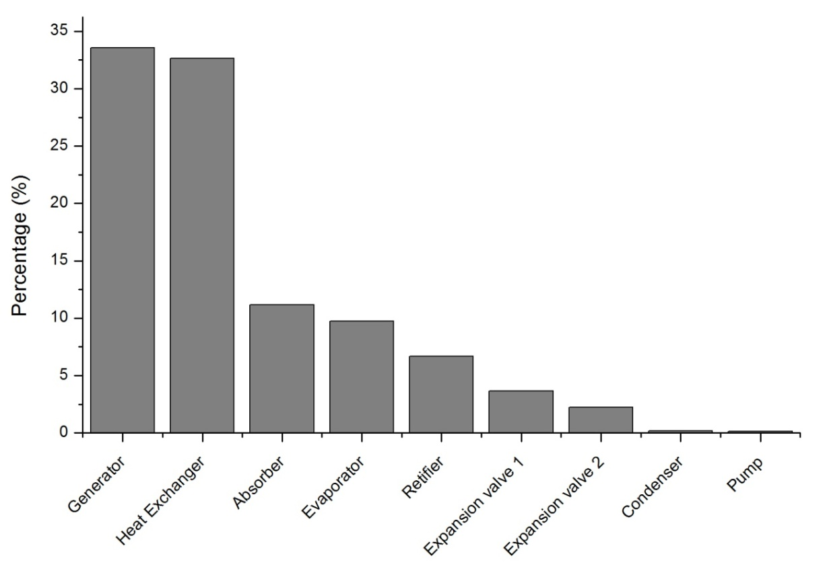
Figure 4. Values in terms of percentages in relation to the total value of irreversibility

It can be noticed that around 34% of the irreversibility occurs in the generator. The second most critical component from the exergy loss perspective is the heat exchanger accounting for about 33%, followed by the absorber, with about 11%, and the evaporator, with approximately 10%. According to [19], the irreversibilities occur mainly in the generator due to the heat transfer associated with the great temperature difference in the absorber and the mass transfer with an elevated concentration gradient and loss of mixtures in the generator. Furthermore, as superheated ammonia comes out of the generator, a higher temperature is necessary under the same pressure, which causes more thermodynamic losses in the generator.
When a rectifier is included in a cycle, there is an increase in irreversibility in the system, nonetheless, it is very important in the ammonia purification to avoid the presence of water in the evaporator, which raises the evaporation temperature significantly and decreases the efficiency of the system.
The calculated of COP in the simulation was 1.212 and the one regarding Exergetic Efficiency was 53.72%.

Effects in some properties for different condensantion temperature

The graphs presented in Figures 5 to 8 show the effects in some properties for condensation temperature from 45°C to 81°C; setting the evaporation temperature at 5°C, the temperature of gases entering the generator (heat source) at 130°C and the heat transferred by the gases entering the generator at 27.23 kW.
Fig. 5, Fig. 6 and Fig. 7 show that an increased condensation temperature results in poorer performance, efficiency and refrigerating power. In Fig. 8, we can see that irreversibility in the heat exchanger, absorber, expansion valve 2 and rectifier rises significantly. On the other hand, irreversibility in the other components does not vary markedly with increasing condensation temperature.

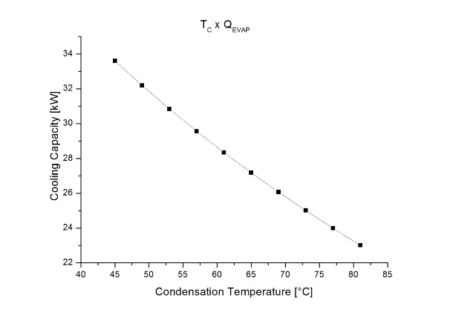
Figure 5. Cooling capacity with increasing condensation temperature

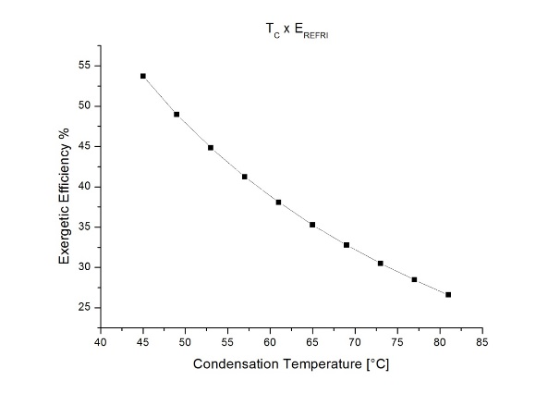
Figure 6. Exergetic efficiency with increasing condensation temperature

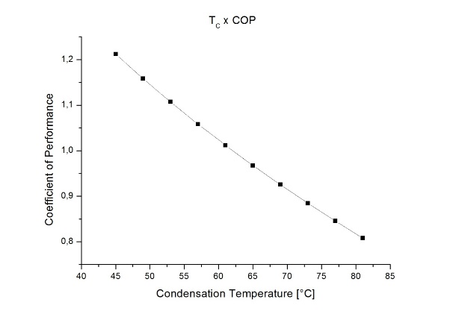
Figure7. COP with increasing condensation temperature

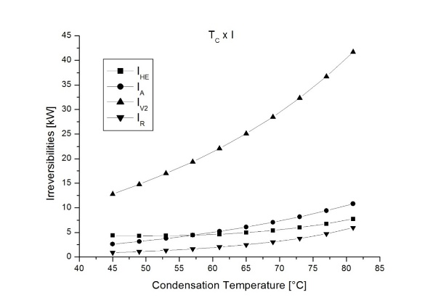
Figure 8. Irreversibilities for components with increasing condensation temperature

Conclusion

The study presented showed an exergetic analysis of a single-effect absorption system with a rectifier at the output of the generator and a water-ammonia working fluid, using a simulation developed in EES.
Despite the fact that the simulation was done considering certain simplifications and suppositions which can make it less accurate than in the real world, it provides an understanding of an absorption refrigeration system operation. This is a useful tool to study and develop such systems as it shows the main critical points of an absorption refrigeration system. The simulation also shows that the system can be used to analyze other systems integrated with heat recovery system using exhaust gases from combustion engines, industrial process steam, power systems in general or even solar power.
As expected, the COP obtained in the simulation was relatively small when compared to compression refrigeration systems. On the other hand, the comparison between the two systems has to be made comprehensively, mainly because of the necessary electricity saving and the energy recovery which is possible in the absorption refrigeration system.
The analysis developed in this study was sufficient to demonstrate that work needed to improve absorption refrigeration systems should concentrate on the development of more efficient components. These include the generator, heat exchanger and absorber, which are responsible for the greatest exergy losses in the whole system.

References

[1] Hong, D., Tang, L., He, Y., Chen, G. A novel absorption refrigeration cycle. Appl. Thermal Eng. 2010;30:2045–2050.

[2] Fong, K.F., Chow, Lee, T.T., Lin, C.K., Chan, Z., L.S. Comparative study of different solar cooling systems for buildings in subtropical city. Sol Energy 2010;84:227–244.

[3] Srikhirin P, Aphornratana S, Chungpaibulpatana S. A review of absorption refrigeration technologies. Renew Sustain Energy Rev 2001;5:343–72.

[4] Jawahar, C.P., Saravanan R. Generator absorber heat exchange based absorption cycle—A review. Renew Sustain Energy Rev 2010;14:2372–2382.

[5] Brown, J. S., Domanski P. A. Review of alternative cooling Technologies.Applied Thermal Engineering, 2014;64:252–262.

[6] Jeong, J.; Saito, K.; Kawai, S. Static characteristics and efficient control of compression- and absorption-type hybrid air conditioning system. International Journal of Refrigeration, 2011;34:674-685.

[7] Cimsit, C., Ozturk, I., T., Horoz, M. Second law based thermodynamic analysis of compression absorption cascade refrigeration cycles. J ThermSciTechnol 2014;34:9-18.

[8] Horuz, I., Callander T.M.S. Experimental investigation of a vapor absorption refrigeration system. International Journal of Refrigeration 2004;27:10–16.

[9] Fernández-Seara J, Sieres J, Vázquez M. Heat and mass transfer analysis of helical coil rectifier in an ammonia–water absorption system. International Journal ThermScience, 2003;42:783–794.

[10] Bogart M.J.P. Pitfalls in ammonia absorption refrigeration.International Journal of Refrigeration 1982;7:203–208.
[11] Fernandez-Seara J, Sier
es J. The importance of the ammonia purification process in ammonia–water absorption systems. Energy Convers Manage 2006; 47:1975–1987.

[12] Zavaleta-Aguilar, E.W., Simões-Moreira J.R. Thermal design of a tray-type distillation column of an ammonia/water absorption refrigeration cycle. Applied Thermal Engineering 2010;1-9.

[13] Karamangil, M.I., Coskun, S., Kaynakli O. Yamankaradeniz N. A simulation study of performance evaluation of single-stage absorption refrigeration system using conventional working fluids and alternatives. Renew Sustain Energy Rev 2010;14:1969–1978.

[14] Klein, S. A. Engineering Equation Solver – EES, Professional 2009; V8.279.

[15] Kaynakli O, Kilic M. Theoretical study on the effect of operating conditions on performance of absorption refrigeration system. Energy Convers Manage 2007;48:599–607.

[16] Adewusi, S.A., Zubair, S.M., Second law based thermodynamic analysis of ammonia-water absortions systems. Energy Convers Manage 2004;45:2355–2369.

[17] Sozen A. Effect of heat exchangers on performance of absorption refrigeration systems.Energy Convers Manage, 2001;42:1699–716.
[18] Almeida, I.M.G., Barbosa, C.R.M., Fontes, F.A.O. Análise exergética de um sistema de refrigeração por absorção de simples efeito operando com par LiBr/H2O. Holos 2010;3:69-81.

[19] Aman, J., Ting, D.S.K., Henshaw, P. Residential solar air conditioning: Energy and exergy analyses of an ammonia-water absorption cooling system. Applied Thermal Engineering 2014;62:424-432.

