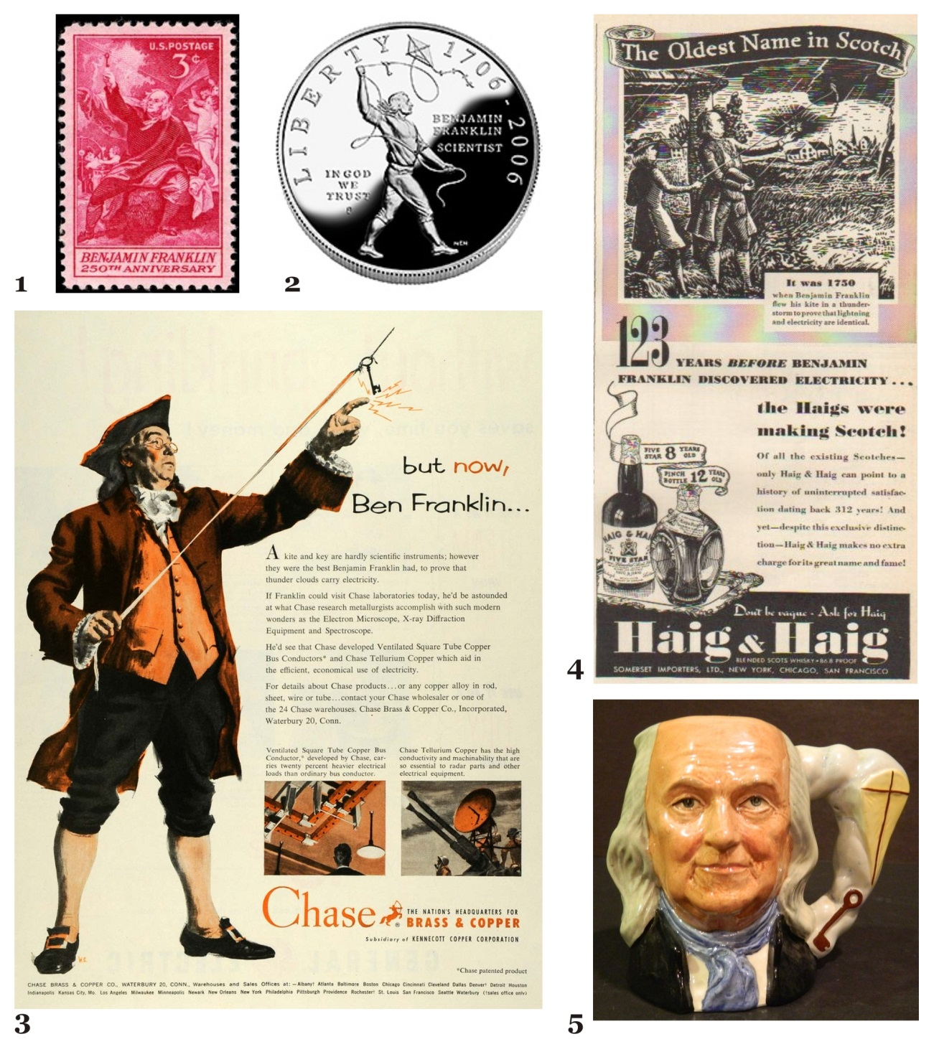 Fig. 1. Some exemplary instances of Franklin’s kite experiment (1) Commemorative stamp of Franklin’s 250 anniversary (2) Silver dollar commemorating his 300th anniversary in 2006 (3) 1953 advertisement of the Chase Brass and Copper Company Inc. (4) 1939 advertisement of the whiskey brand Haig & Haig Five Star Pinch Scotch (5) Franklin themed beer jar (Source: author’s private collection).

Figure 1

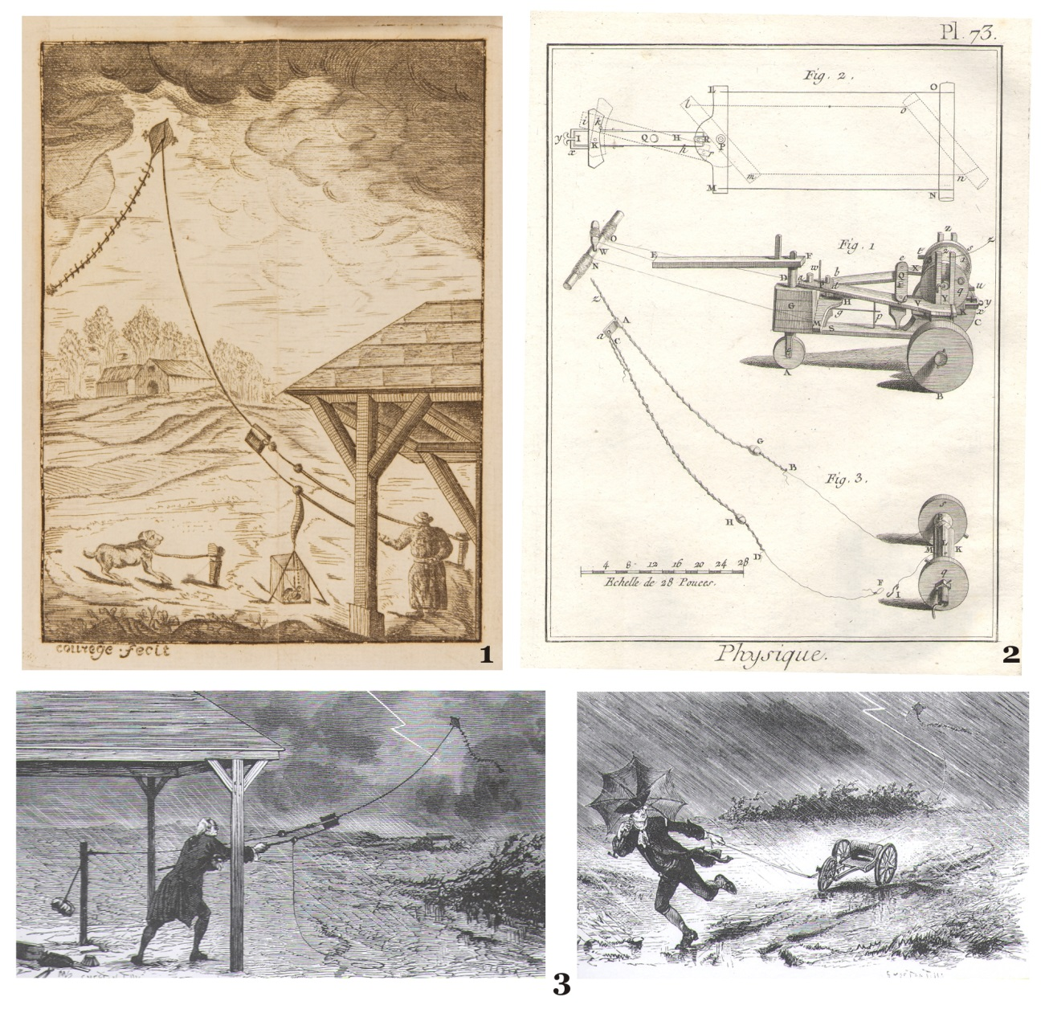
Fig. 2. (1) Engraving of Romas’ experiment in Romas, Jacques de, Mémorire, sur les Moyens de se Garantir de la Foudre dans les Maisons (Bordeaux, 1776). (2) Engraving of Romas’ electrical cart in Brisson, Mathurin Jacques, Dictionnaire Raisonné de Physique (Paris: Thou, 1781-1800). (3) Engraving of the French magazine La Nature (1877), describing Roma’s experiments. Girard, Maurice, “Les Manieurs de Foudre,” La Nature, 1877, 191, 27 Janvier: 134-137.

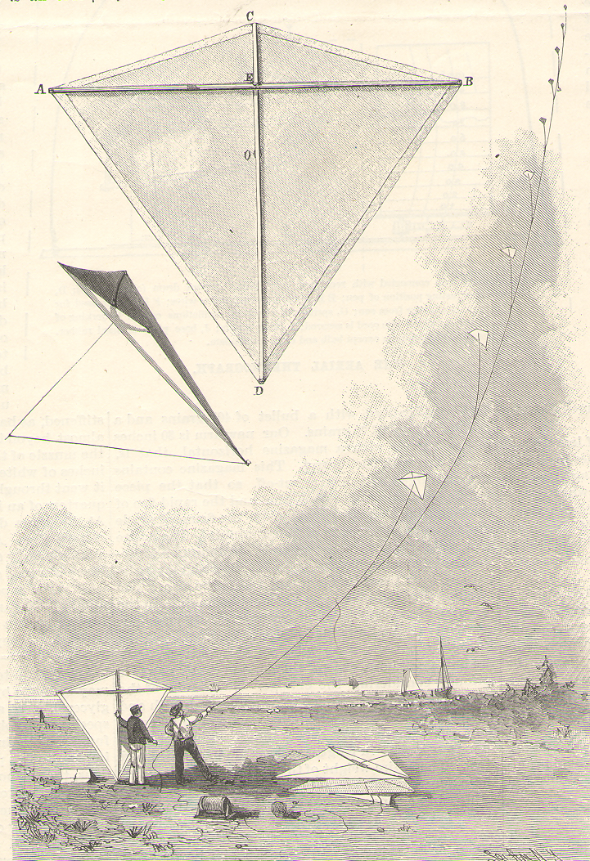
Fig. 3. Eddy’s kite train in the Blue Hill observatory. Clayton, H. H., “The Eddy Malay Tailles Kite,” Scientific American, 1894, September, 15: 169-170, 1894, p. 169.

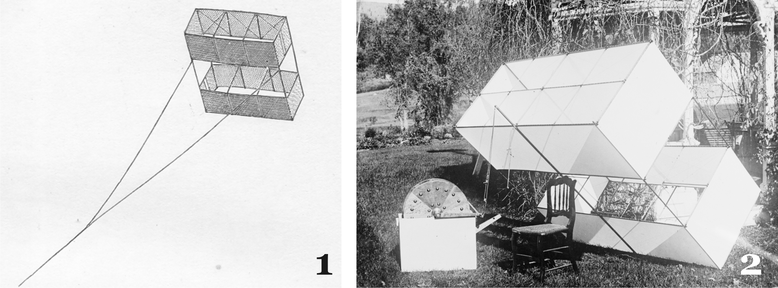
Fig. 4. (1) Hargrave’s kite in Rotch, Lawrence, Sounding the Ocean of Air (New York, E & J. B. Young & Co, 1900), p.130. (2) Meteorological Marvin-Hargrave kite used by U.S. Weather Bureau (Source: author’s private collection).

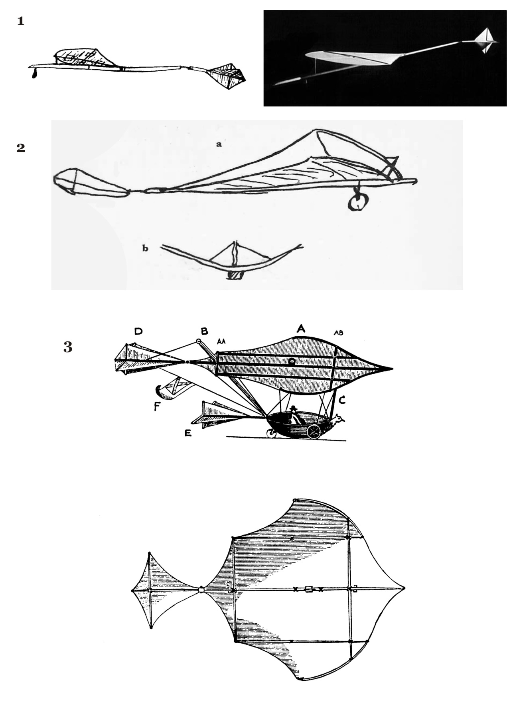
Fig. 5. Cayley’s gliders: (1) 1804. (2) 1818. (3) Governable Parachute (1852) in Gibbs-Smith, Sir George Cayley (cit. note 63), pp.17, plate II, 85, 151.
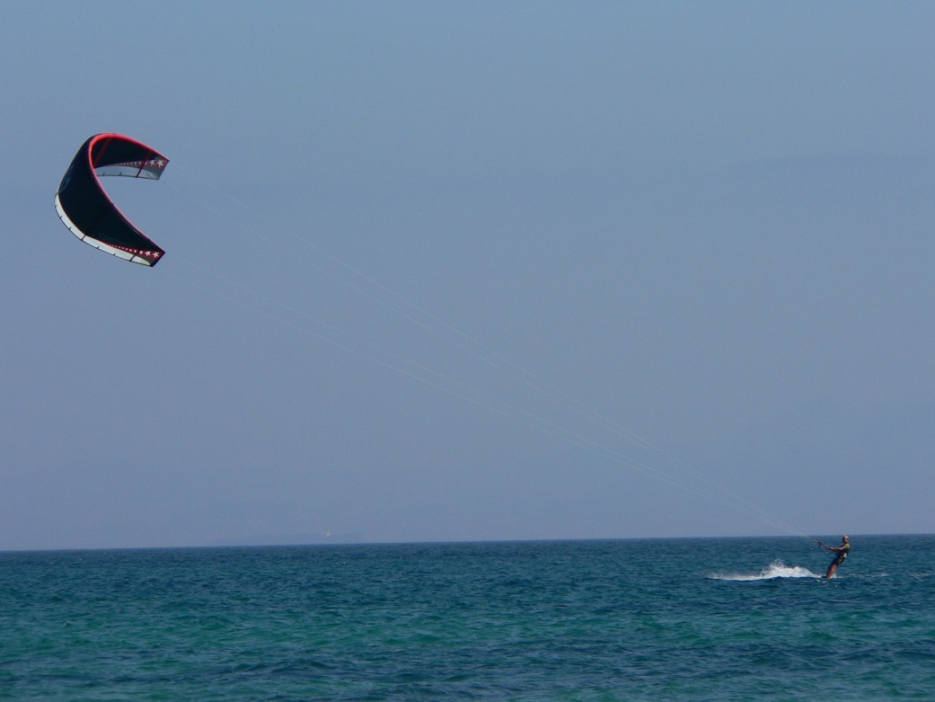
Fig. 6. Kite-surfing in Punta Taloma, Tarifa (Spain), © Manuel González Olaechea y Franco (http://upload.wikimedia.org/wikipedia/commons/0/05/Kitesurfing.JPG).

